Week 06

**Question 1:**

**Given an array A of sorted integers and another non negative integer k, find if there exists 2 indices i and j such that A[i] - A[j] = k, i != j.**

**Input Format:**

**1. First line is number of test cases T. Following T lines contain:**

**2. N, followed by N integers of the array**

**3. The non-negative integer k**

**Output format: Print 1 if such a pair exists and 0 if it doesn’t.**

**Program:**

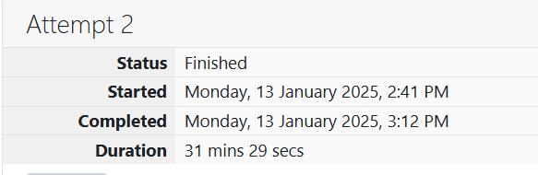

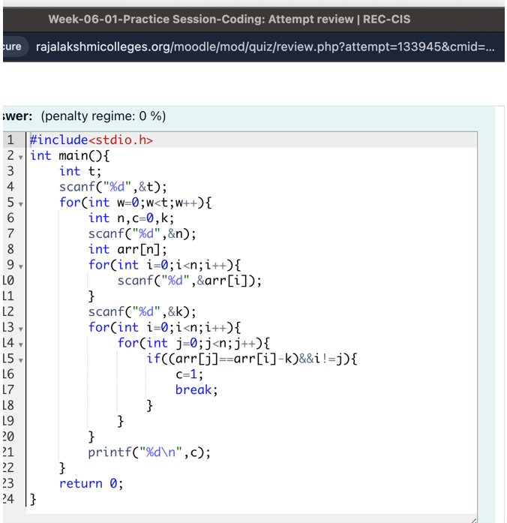

**Output:**

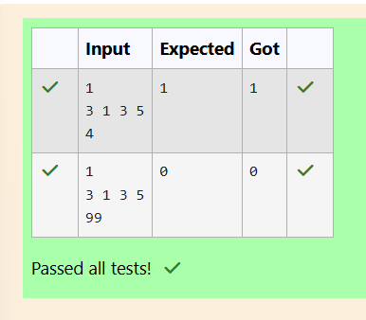

**Question 2:**

**Sam loves chocolates and starts buying them on the 1st day of the year. Each day of the year, x, is numbered from 1 to Y. On days when x is odd, Sam will buy x chocolates; on days when x is even, Sam will not purchase any chocolates. Complete the code in the editor so that for each day Ni (where 1 ≤ x ≤ N ≤ Y) in array arr, the number of chocolates Sam purchased (during days 1 through N) is printed on a new line. This is a function-only challenge, so input is handled for you by the locked stub code in the editor.**

**Input Format:**

**The program takes an array of integers as a parameter.** **The first line of input contains an integer, T (the number of test cases). Each line i of the T subsequent lines describes the ith test case as an integer, Ni (the number of days).**

**Program:**



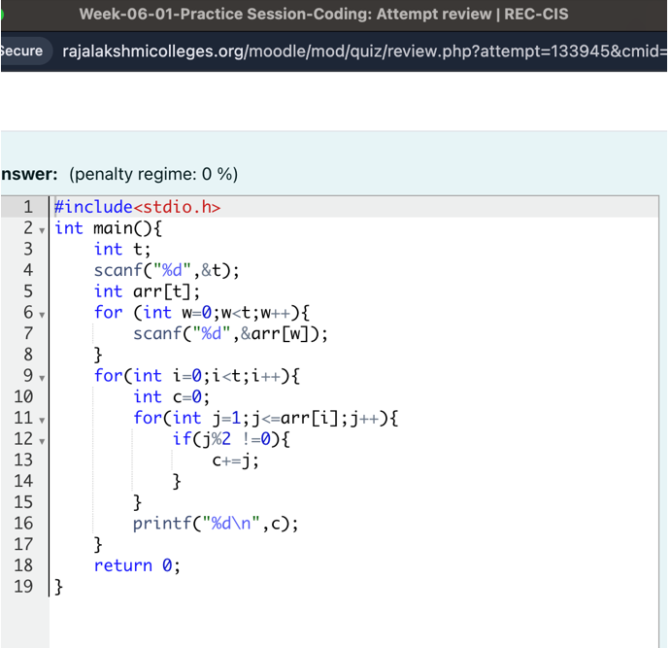

**Output:**

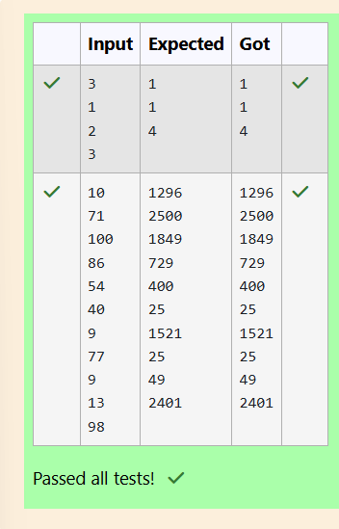

**Question 3:**

**The number of goals achieved by two football teams in matches in a league is given in the form of two lists.**

**• Football team A, has played three matches, and has scored { 1 , 2 , 3 } goals in each match respectively.**

**• Football team B, has played two matches, and has scored { 2, 4 } goals in each match respectively.**

**• Your task is to compute, for each match of team B, the total number of matches of team A, where team A has scored less than or equal to the number of goals scored by team B in that match.**

**• For 2 goals scored by team B in its first match, team A has 2 matches with scores 1 and 2.**

**• For 4 goals scored by team B in its second match, team A has 3 matches with scores 1, 2 and 3.**

**Hence, the answer: {2, 3}.**

**Program: **

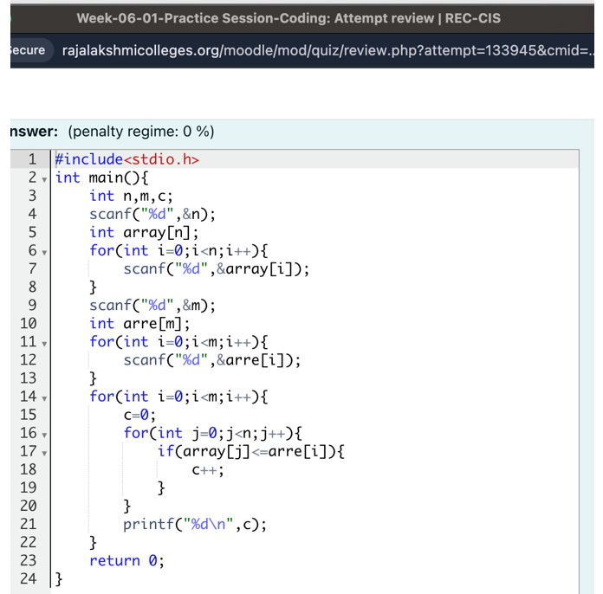

**Output:**

